Experiment 10

**Aim:** Aim: WAP in Tinkercad to develop a weather station on tinkercad using RGB, LDR, LM36, Buzzer and LCD.

**Apparatus:**

* LDR
* LM36
* Arduino Uno
* Buzzer

**Theory:**

**LDR**

A Light Dependent Resistor (also known as a photoresistor or **LDR**) is a device whose resistivity is a function of the incident electromagnetic radiation. Hence, they are light-sensitive devices. They are also called as photoconductors, photoconductive cells or simply photocells.

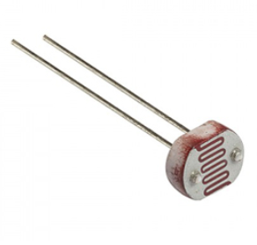

**Arduino UNO**

The Arduino Uno is a microcontroller board based on the ATmega328. It has 14 digital input/output pins (of which six can be used as PWM outputs), six analog inputs, a 16 MHz crystal oscillator, a USB connection, a power jack, an ICSP header, and a reset button. It contains everything needed to support the microcontroller; simply connect it to a computer with a USB cable or power it with an AC-to-DC adapter or battery to get started.

The Arduino Uno differs from all preceding boards because it does not use the FTDI USB-to-serial driver chip. Instead, it features the ATmega8U2 programmed as a USB-to-serial converter. Revision 2 of the Arduino Uno board has a resistor pulling the 8U2 HWB line to ground, making it easier to put into DFU mode.

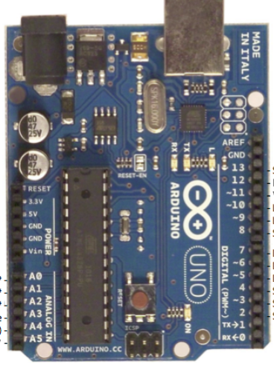

|  |  |
| --- | --- |
| **Features** |  |
| * 14 digital I/O pins (six of which provide PWM output) * 3.3 V supply generated by an on-board regulator * Six analog input pins * 32 KB of flash memory | * Can supply 40 mA of DC current per pin * 16 MHz clock speed * Code example from Arduino website to help get started |

**Buzzer**

A **buzzer** or beeper is an audio signalling device, which may be mechanical, electromechanical, or piezoelectric (piezo for short). Typical uses of **buzzers** and beepers include alarm devices, timers, and confirmation of user input such as a mouse click or keystroke.

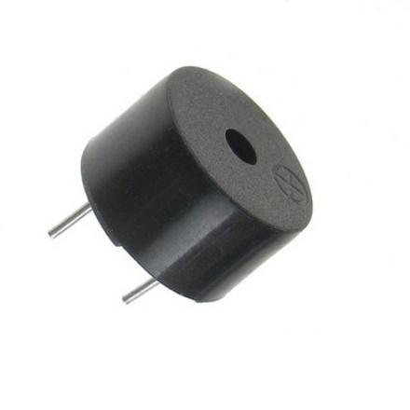

**LM36**

The **TMP36 temperature sensor** is an easy way to measure **temperature** using an **Arduino**! The **sensor** can measure a fairly wide range of **temperature** (-50°C to 125°C), is fairly precise (0.1°C resolution), and is very low cost, making it a popular choice.

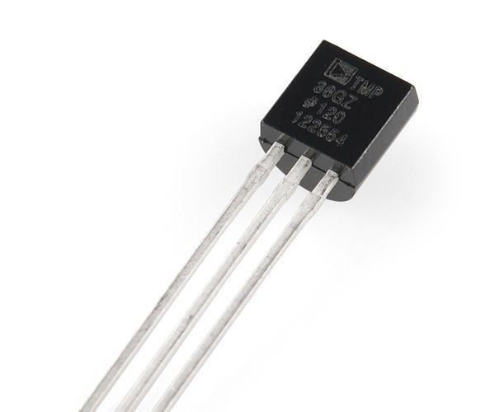

**Circuit:**

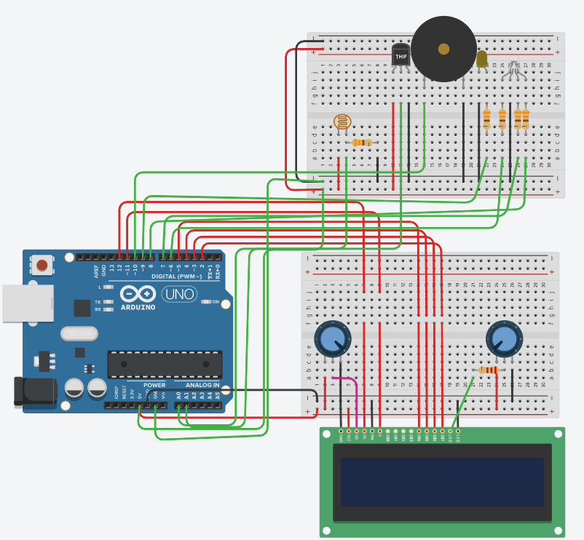

**Code:**

#include <LiquidCrystal.h>

LiquidCrystal lcd(12, 11, 5, 4, 3, 2);

int wLED = 9;

int lightLevel = 0;

int LDR = A0;

int TMP = A1;

int rLED = 6;

int bLED = 7;

int gLED = 8;

int sensorPin = A1;

void setup() {

Serial.begin(9600);

lcd.begin (16, 2);

pinMode(wLED, OUTPUT);

pinMode(rLED, OUTPUT);

pinMode(bLED, OUTPUT);

pinMode(gLED, OUTPUT);}

void loop() {

int reading = analogRead(sensorPin);

float voltage = reading * 5.0;

voltage /= 1024.0;

Serial.print(voltage); Serial.println(" volts");

float temperatureC = (voltage - 0.5) * 100 ;

lightLevel = analogRead(LDR);

Serial.println(lightLevel);

if (lightLevel < 10) {

digitalWrite(wLED, HIGH);

} else {

digitalWrite(wLED, LOW);}

lcd.clear();

lcd.setCursor(0, 0);

if (temperatureC < 2) {

digitalWrite(bLED, HIGH);

digitalWrite(rLED, LOW);

lcd.print("Cold Weather");

lcd.setCursor(0, 1);

lcd.print(temperatureC);

tone(10, 260);

} else if (temperatureC >= 2 && temperatureC < 45){

digitalWrite(bLED, LOW);

digitalWrite(rLED, LOW);

lcd.setCursor(0, 0);

lcd.print("Normal Weather");

noTone(10);

} else {

digitalWrite(rLED, HIGH);

digitalWrite(bLED, LOW);

lcd.setCursor(0, 0);

lcd.print("Hot Weather");

lcd.setCursor(0, 1);

lcd.print(temperatureC);

tone(10, 260);}

delay (500);}

**Result:**

